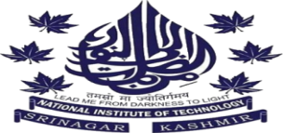
___________________________________________________________
NATIONAL INSTITUTE OF TECHNOLOGY SRINAGAR
(An Autonomous Institute of National Importance Established by the Act of Parliament)
LIBRARY & INFORMATION RESOURCE CENTRE, (LIRC)
Email: office_library@nitsri.net website: http://nitsri.ac.in
_________________________________________________________

LIRC- STAFF
S. No. | Name | Designation | Contact Details
1 | Mrs. Asmat Ali | Deputy Librarian | Email ID: deputylibrarian@nitsri.net  Mobile: 9797847219
2 | Mr. Showkat Ahmad Wani | Assistant Librarian | Email ID: assistantlibrarian@nitsri.net  Mobile: 9149507396
3 | Mr. Mohd Yousuf Rather | Sr. Technical Assistant | Email ID: Yousuf0886@gmsilmail.com
4 | Mrs.Tahira | Sr. Technical Assistant
5 | Mrs. Dilshada | Sr. Assistant (SG-1)
6 | Mr. Mohd Yaseen Akhoon | Sr. Technician
7 | Mrs. Shabir Ahmad Sheikh | Technical Assistant
8 | Mrs. Noor Mohd. Sofi | Sr. Technician
9 | Mr. Irfan Ahmad Wani | Jr. Assistant
10 | Supporting Staff | 06

