Paste Your Title Here Paste Your Title Here
Paste Your Title Here Paste Your Title Here

Major project report submitted in partial fulfilment of the
requirements for the award of the degree of

Bachelor of Technology in Electrical Engineering

By
Student Name (Enrollment Number)
Student Name (Enrollment Number)
Student Name (Enrollment Number)
Student Name (Enrollment Number)

Under the guidance of
Faculty Name



Department of Electrical Engineering
National Institute of Technology Srinagar
Srinagar, Jammu and Kashmir - 190006. (India)

CERTIFICATE

It is to certify that the contents of the report entitled “Paste Your Title Here” is a bonafide work carried out by Mr. Student Name (Enrollment number), Mr. Student Name (Enrollment number), Mr. Student Name (Enrollment number) and Student Name (Enrollment number) under my supervision and guidance in partial fulfillment of the requirements for the award of the degree of Bachelor of Technology in Electrical Engineering. The contents of the report have not been submitted earlier for the award of any other degree or certificates and I hereby commend the work done by them in this connection.

(Supervisor Name)
Department of Electrical Engineering
National Institute of Technology Srinagar
Srinagar, Jammu and Kashmir, India

CERTIFICATE OF APPROVAL

This project titled “Paste Your Title Here” carried out by Mr. Student Name (Enrollment number), Mr. Student Name (Enrollment number), Mr. Student Name (Enrollment number) and Student Name (Enrollment number), is hereby approved as the creditable study of technology in Electrical Engineering and is presented in a satisfactory manner.
It warrants its acceptance as a prerequisite in fulfillment of the requirements for the award of the degree of Bachelor of Technology in Electrical Engineering at National Institute of Technology Srinagar, J&K.

Internal Examiner External Examiner

(HoD Name)
Head
Department of Electrical Engineering,
National Institute of Technology Srinagar,
Srinagar, J&K

ACKNOWLEDGEMENT

The acknowledgement must be written by the student himself.

Student Name (Enrollment Number)
Student Name (Enrollment Number)
Student Name (Enrollment Number)
Student Name (Enrollment Number)

ABSTRACT

Word limits 300-350 including space. Write text here to develop an apparatus to trace the current-voltage and power voltage curve of photovoltaic module and extract the principal parameters like short-circuit current, open circuit voltage, voltage and current at the maximum power point and maximum power that can be produced
Write text here to develop an apparatus to trace the current-voltage and power voltage curve of photovoltaic module and extract the principal parameters like short-circuit current, open circuit voltage, voltage and current at the maximum power point and maximum power that can be produced

TABLE OF CONTENT
Acknowledgement………………………………………………………………….….…3
Abstract………………………………………………………………….………..….…...4
Abbreviations………………………………………………………………………….….6
List of Tables……………………………………………………………………………..7
List of Figures……………………………………………………………………………8

ABBREVIATIONS

J | Current density
q | Charge on electron (1.6e-19 C)
K | Boltzmann’s constant
n | Total number of atoms/cm³ Drift velocity (cm/s)
V_{d} | Drift velocity
Io-ref | Diode saturation current at reference condition

LIST OF TABLES

Table 1.1 | Insert table caption
Table 1.2 | Insert table caption
Table 2.1 | Insert table caption
Table 2.2 | Insert table caption

LIST OF FIGURES

Figure 1.1 | Insert figure caption
Figure 1.2 | Insert figure caption
Figure 2.1 | Insert figure caption
Figure 2.2 | Insert figure caption

CHAPTER 1

INTRODUCTION
Write text here to develop an apparatus to trace the current-voltage and power voltage curve of photovoltaic module and extract the principal parameters like short-circuit current, open circuit voltage, voltage and current at the maximum power point and maximum power that can be produced.
Write text here to develop an apparatus to trace the current-voltage and power voltage curve of photovoltaic module and extract the principal parameters like short-circuit current, open circuit voltage, voltage and current at the maximum power point and maximum power that can be produced

  - SECTION
To develop an apparatus to trace the current-voltage and power voltage curve of photovoltaic module and extract the principal parameters like short-circuit current. To write the mathematical equation, use Microsoft equation tab (Follow: Insert+Equation). Images for the equations are not allowed.
The fitness function of the chromosome is calculated using the following equation:
$I\left(V_{i},θ\right)=I_{ph}-I_{S}\left[exp\left(\frac{q\left(V_{i}+R_{s}I\right)}{nKT}\right)-1\right]$ (1.1)
The evaluated function of the participants is calculated using the following equation:
$∂\left(V_{i},θ\right)=V_{ph}-V_{S}\left[exp\left(\frac{q\left(V_{i}+R_{s}I\right)}{nKT}\right)-240\right]$ (1.2)

    - SUB-SECTION
Write text here.
If points will be added, then follow the below style
- To develop an apparatus to trace the current-voltage and power voltage curve of photovoltaic module.
- Extract the principal parameters like short-circuit current, open circuit voltage, voltage.
- Current at the maximum power point and maximum power that can be produced.

    - SUB-SECTION
To develop an apparatus to trace the current-voltage and power voltage curve of photovoltaic module and extract the principal parameters like short-circuit current, open circuit voltage, voltage and current at the maximum power point and maximum power that can be produced.
Table 1.1: Specifications of HBL PV Module (Table in the form of image is not allowed/prohibited)
Sr. no | Description | Rating
1 | Number of Cells | 36
2 | Voltage at Maximum Power, Vmpp (V) | 17.0 V
3 | Current at Maximum Power, Impp (A) | 4.41 A
4 | Tolerance | -5% to +5%

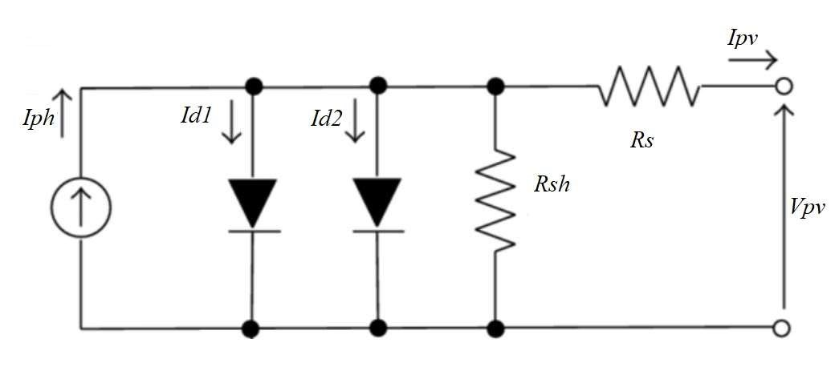

Figure 1.1: Basic structure of reverse biased diode (Figure resolution should be 300 DPI, and it should be of suitable dimension and clear)

  - SECTION
To develop an apparatus to trace the current-voltage and power voltage curve of photovoltaic module and extract the principal parameters like short-circuit current, open circuit voltage, voltage and current at the maximum power point and maximum power that can be produced.
    - SUB-SECTION
Write text here.
If points will be added, then follow the below style
- To develop an apparatus to trace the current-voltage and power voltage curve of photovoltaic module.
- Extract the principal parameters like short-circuit current, open circuit voltage, voltage.
- Current at the maximum power point and maximum power that can be produced.

    - SUB-SECTION
Write text here.
If points will be added, then follow the below style
- To develop an apparatus to trace the current-voltage and power voltage curve of photovoltaic module.
- Extract the principal parameters like short-circuit current, open circuit voltage, voltage.
- Current at the maximum power point and maximum power that can be produced.

CHAPTER 2

LITERATURE REVIEW
Write text here to develop an apparatus to trace the current-voltage and power voltage curve of photovoltaic module and extract the principal parameters like short-circuit current, open circuit voltage, voltage and current at the maximum power point and maximum power that can be produced.
Table 2.1: Specifications of HBL PV Module (Table in the form of image is not allowed/prohibited)
Sr. no | Description | Rating
1 | Number of Cells | 36
2 | Voltage at Maximum Power, Vmpp (V) | 17.0 V
3 | Current at Maximum Power, Impp (A) | 4.41 A
4 | Tolerance | -5% to +5%

Figure 2.1: Basic structure of reverse biased diode (Figure resolution should be 300 DPI, and it should be of suitable dimension and clear)

Write text here to develop an apparatus to trace the current-voltage and power voltage curve of photovoltaic module and extract the principal parameters like short-circuit current, open circuit voltage, voltage and current at the maximum power point and maximum power that can be produced

  - SECTION
Sample text: A maximum power point tracking (MPPT) algorithm based on an incremental conductance algorithm [1] is used to operate the solar DGs at its maximum power point all of the time and is integrated with the inverter controller [2].To develop an apparatus to trace the current-voltage and power voltage curve of photovoltaic module and extract the principal parameters like short-circuit current [4], open circuit voltage, voltage and current at the maximum power point and maximum power that can be produced [5].
2.1.1 SUB-SECTION
Write text here.
If points will be added, then follow the below style
- To develop an apparatus to trace the current-voltage and power voltage curve of photovoltaic module.
- Extract the principal parameters like short-circuit current, open circuit voltage, voltage.
- Current at the maximum power point and maximum power that can be produced.

CHAPTER 3

MATHEMATICAL FORMULATION / SIMULATION MODEL
Write text here to develop an apparatus to trace the current-voltage and power voltage curve of photovoltaic module and extract the principal parameters like short-circuit current, open circuit voltage, voltage and current at the maximum power point and maximum power that can be produced.
Write text here to develop an apparatus to trace the current-voltage and power voltage curve of photovoltaic module and extract the principal parameters like short-circuit current, open circuit voltage, voltage and current at the maximum power point and maximum power that can be produced

  - SECTION
To develop an apparatus to trace the current-voltage and power voltage curve of photovoltaic module and extract the principal parameters like short-circuit current, open circuit voltage.
To write the mathematical equation, use Microsoft equation tab (Follow: Insert+Equation). Images for the equations are not allowed.
The fitness function of the chromosome is calculated using the following equation:
$I\left(V_{i},θ\right)=I_{ph}-I_{S}\left[exp\left(\frac{q\left(V_{i}+R_{s}I\right)}{nKT}\right)-1\right]$ (3.1)
The evaluated function of the participants is calculated using the following equation:
$∂\left(V_{i},θ\right)=V_{ph}-V_{S}\left[exp\left(\frac{q\left(V_{i}+R_{s}I\right)}{nKT}\right)-240\right]$ (3.2)
3.1.1 SUB-SECTION
Write text here.
If points will be added, then follow the below style
- To develop an apparatus to trace the current-voltage and power voltage curve of photovoltaic module.
- Extract the principal parameters like short-circuit current, open circuit voltage, voltage.
- Current at the maximum power point and maximum power that can be produced.

CHAPTER 4

RESULTS AND DISCUSSIONS
Write text here to develop an apparatus to trace the current-voltage and power voltage curve of photovoltaic module and extract the principal parameters like short-circuit current, open circuit voltage, voltage and current at the maximum power point and maximum power that can be produced.
Write text here to develop an apparatus to trace the current-voltage and power voltage curve of photovoltaic module and extract the principal parameters like short-circuit current, open circuit voltage, voltage and current at the maximum power point and maximum power that can be produced

  - SECTION
To develop an apparatus to trace the current-voltage and power voltage curve of photovoltaic module and extract the principal parameters like short-circuit current, open circuit voltage, voltage and current at the maximum power point and maximum power that can be produced.
4.1.1 SUB-SECTION
Write text here.
If points will be added, then follow the below style
- To develop an apparatus to trace the current-voltage and power voltage curve of photovoltaic module.
- Extract the principal parameters like short-circuit current, open circuit voltage, voltage.
- Current at the maximum power point and maximum power that can be produced.

CHAPTER 5

CONCLUSION
Write text here (Words limit 350-400 including space) To develop an apparatus to trace the current-voltage and power voltage curve of photovoltaic module and extract the principal parameters like short-circuit current, open circuit voltage, voltage and current at the maximum power point and maximum power that can be produced.
Write text here To develop an apparatus to trace the current-voltage and power voltage curve of photovoltaic module and extract the principal parameters like short-circuit current, open circuit voltage, voltage and current at the maximum power point and maximum power that can be produced

REFERENCES
- Y. Xiao, Y. H. Song, C.-C. Liu, and Y. Z. Sun, “Available transfer capability enhancement using FACTS devices,” IEEE Trans. Power Syst., vol. 18, no. 1, pp. 305–312, Feb. 2003 (reference style for journal paper)
- Cross Texas Transmission, Salt fork to gray project. 2014. [Online]. Available: http://www.crosstexas.com/SFWind.htm (reference style for website link)
- S. A. Rahman and R. K. Varma, “PSCAD/EMTDC model of a 3-phase grid connected photovoltaic solar system,” in Proc. 43rd North Amer. Power Symp., Boston, MA, USA, 2011, pp. 1–5. (reference style for conference paper)
- M. H. Rashid, Power Electronics Handbook. London, U.K.: Academic, 2001, pp. 355,363–364 (reference style for book)

APPENDIX (if any)
To develop an apparatus to trace the current-voltage and power voltage curve of photovoltaic module and extract the principal parameters like short-circuit current, open circuit voltage, voltage and current at the maximum power point and maximum power that can be produced.
Write text here to develop an apparatus to trace the current-voltage and power voltage curve of photovoltaic module and extract the principal parameters like short-circuit current, open circuit voltage, voltage and current at the maximum power point and maximum power that can be produced

