नं./No.: एनआईटी/NIT/../Counselling cell/23/04
दिनांक/Dated:14-05-2023

Notice
The meeting of volunteers of counseling cell will be held on 15th May 2023 in Room no. L-09 at 4:30 p.m. During this meeting, training sessions will be conducted for handling the students. You are requested to attend the meeting

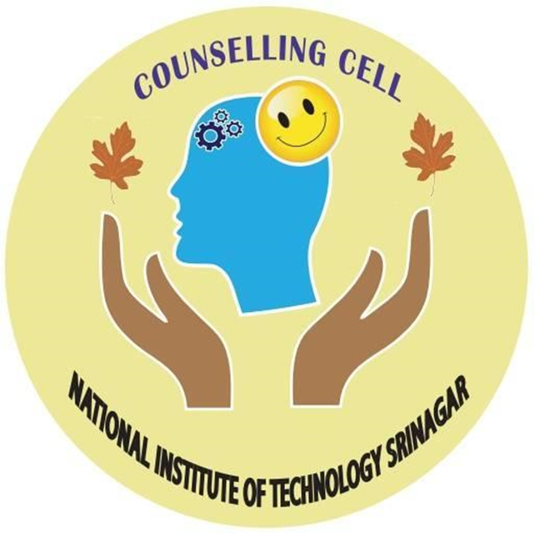
(डॉ. नीरज गुप्ता/Dr. Neeraj Gupta)
प्रभारी परामर्श प्रकोष्ठ/ I/C Counselling Cell,
एनआईटी श्रीनगर/NIT Srinagar
जम्मू एंड कश्मीर/J&K
मोबाइल/Mob:-8958054648
neerajgupta@nitsri.net

Copy to the following:
- Dean (Student & Welfare), NIT Srinagar (J & K) for information, please.
- Circulation File, Counselling Cell for record.

