Members
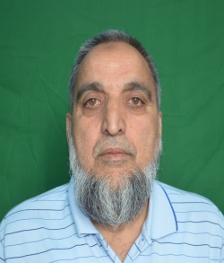
Prof. M.F. Wani
Department of Mechanical Engineering
Chairman CRFC
Email: mfwani@nitsri.net
Dr. Mohd Nadeem Bhat  Scientific / Technical Officer CRFC  Email: nadeembhat@nitsri.ac.in | 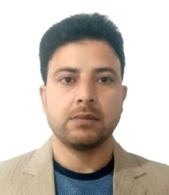 | Dr. S. Shahid Saleem  Mechanical Engineering  Email: shahid@nitsri.ac.in | 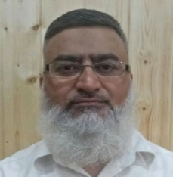
Prof. J.A. Bhat  Civil Engineering  Email: bhat_javed@nitsri.net | 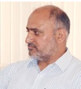 | Prof. Najeebuddin  Electronics and Communication Engineering  Email: najeeb@nitsri.net | 
Prof. Shakeel Ahmad Shah  Chemistry  Email: shakeelshah11@yahoo.in |  | Prof. Atik ur Rahman  Metallurgical & Materials Engineering  Email: atikurrhmn@nitsri.net | 
Prof. M A Shah  Department of Physics  Member  Email: Shah@nitsri.net |  | Dr. Mushtaq A Rather  Department of Chemical Engg  Email: marather@nitsri.net | 
Prof. Mohammad Abid Bazaz  Electrical Engineering  Email: abid@nitsri.net |  | Dr. Shrikant S Maktedar  Chemistry  Email: shrikant@nitsri.net | 
Dr. Mohd Zubair Ansari  Physics  Email: mohdzubair@nitsri.ac.in | 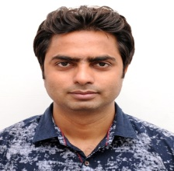 | Dr. Harkirat Singh  Physics  Email: harkirat@nitsri.net | 

